Distributed loose ends

1. Add dates for each play AND tournament. Example:

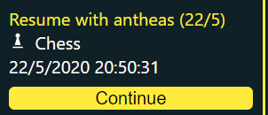

1. Fix Scores column to include tournament information, including:
   1. ALL tournament games
   2. Tournament Leaderboard (With the number of wins for each player in the leaderboard).

The number of wins for each player in the leaderboard is returned by the API.

1. Display ELO as the score of a player in a game.

Remove (You) and just make the current user bold. Example:

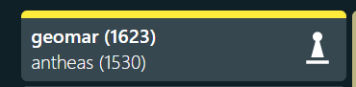

1. In tournament games also display the round id:

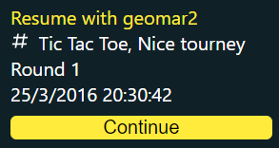

I have already added Round number to the TournamentPlay, the only thing needed is to display it in the UI.

1. JWT tokens are not refreshed. They should be if they expire. (Currently they are only refreshed when we reload the webpage)